Azure Migrate

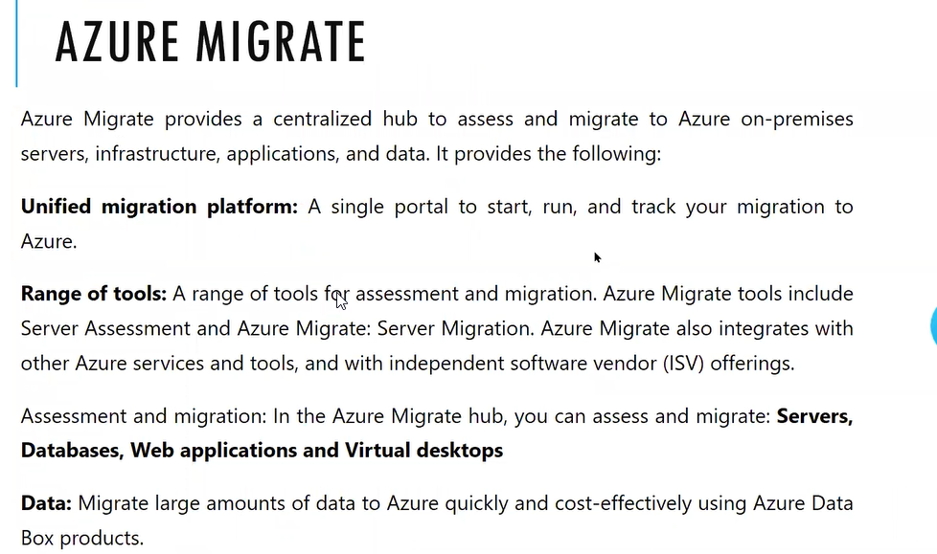

Dedicated tool for migration. Replication is a kind of migration. In Replication if you fail over then First VM will be shutdown then source is needed

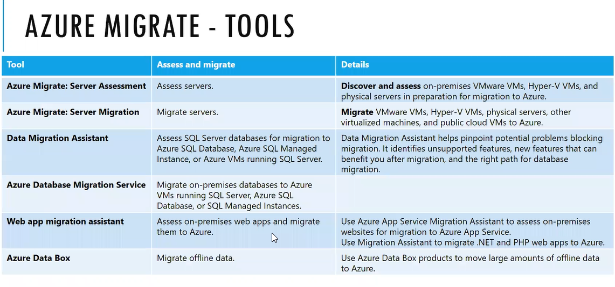

Server assignment tools: It will analysis or monitor

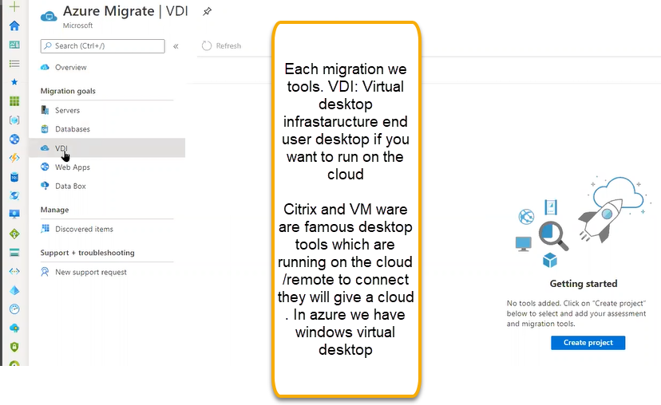

Initially we need to create the project

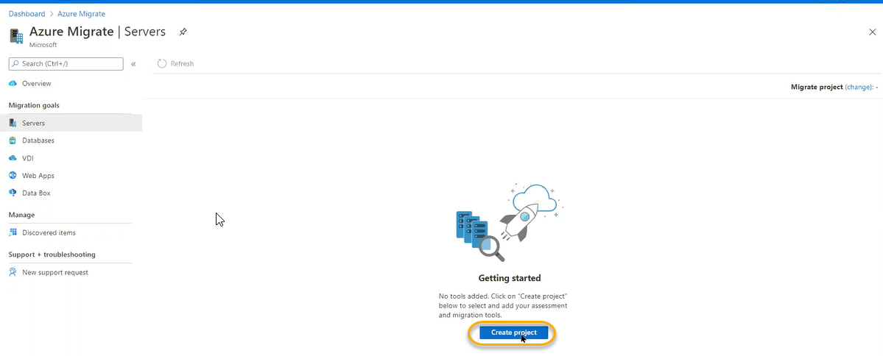

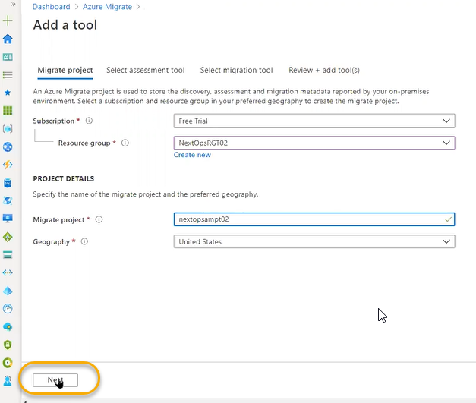

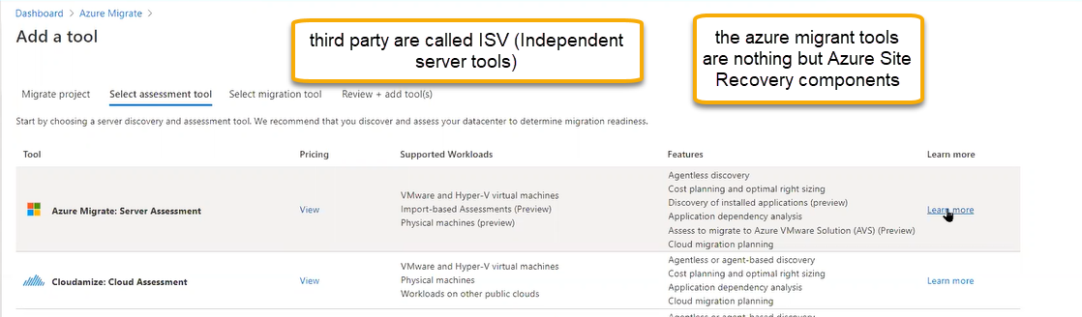

If you want we can select the azure provided assessment tool and migration tools

In ASR while connecting to on premises we have host configuration and cpsc configuration in the same way we can see the same tools in the migrate tools

1. Azure Migrate we need to create the migrate project and we need to select assignment tools, migration tools accordingly migrate will start
2. We need to download the azure migrate appliance. We can download it three ways based on the project if it is physical server, we can simply download it if is it is hyper v, VM ware we need to download the OVA file
3. 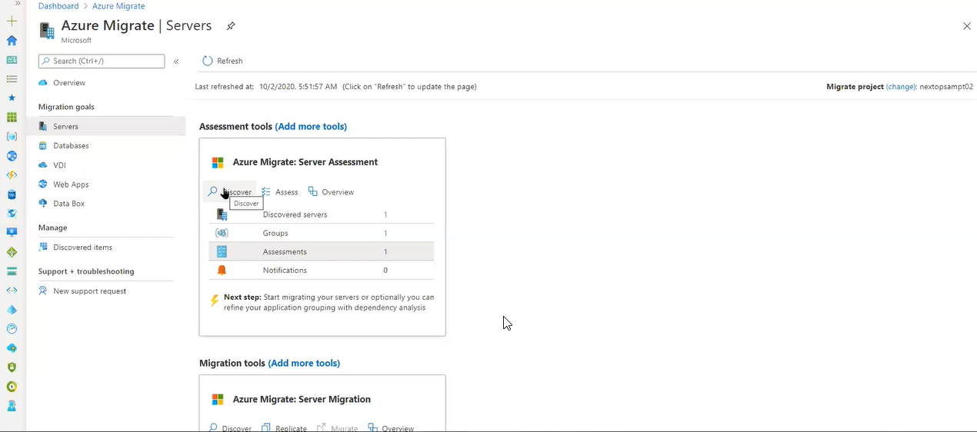
4. 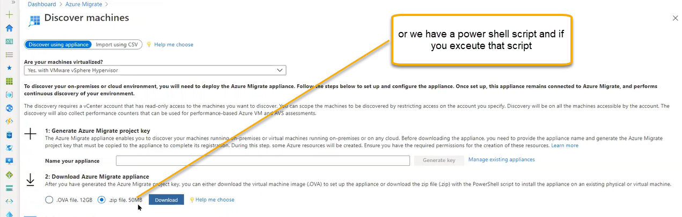
5. OVA is open virtualization platform no need to do any further installations we will get predefined installation. and if you download the file of 50 MB a script will be downloaded
6. 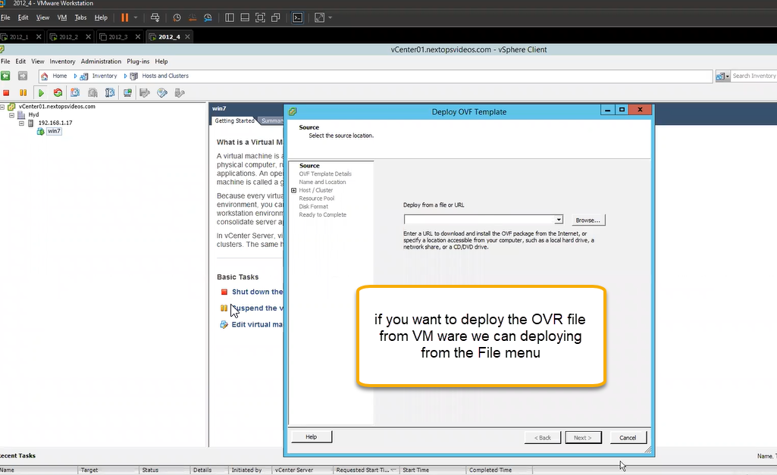
7. 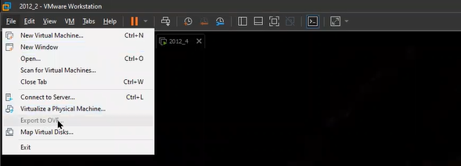
8. In that way machine is added
9. Take any VM ware machine and download the Azure migrate appliance zip file

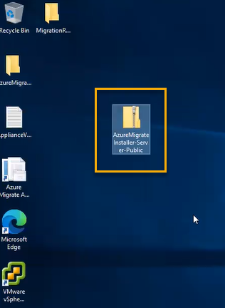

1. And if you extract we will see all the files related to assessment and I.E

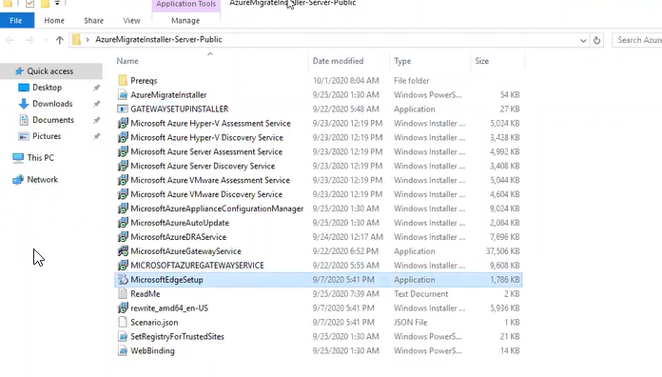

1. Take the powers shell
2. 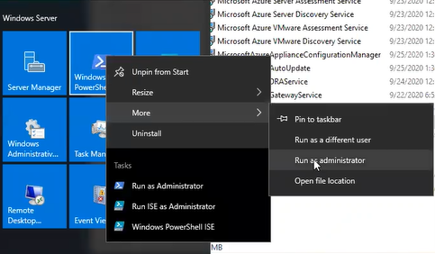

Give the file path in the power shell where the azure migrate shell is installed

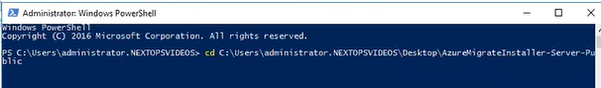

And follow the below process

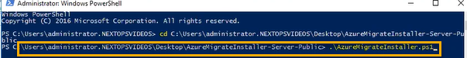

And after the select the default process as Next > Next and we see the shortcut file is created

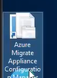

If you launch that we can see that it directly opens in the I.E

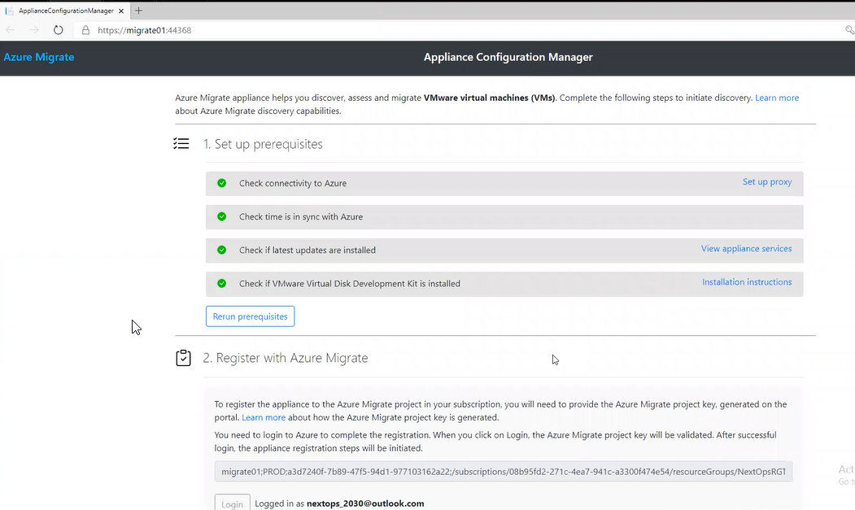



If we execute it will automatic msi will be installed

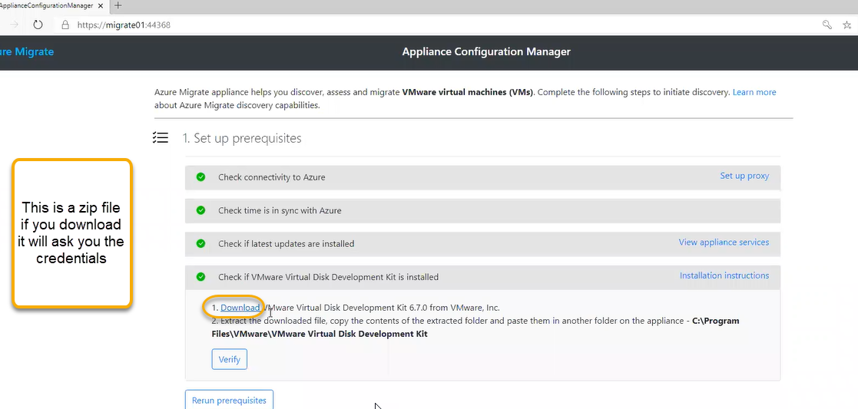

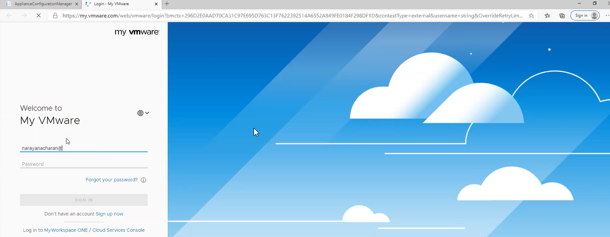

After entering the credentials we need to download the zip file

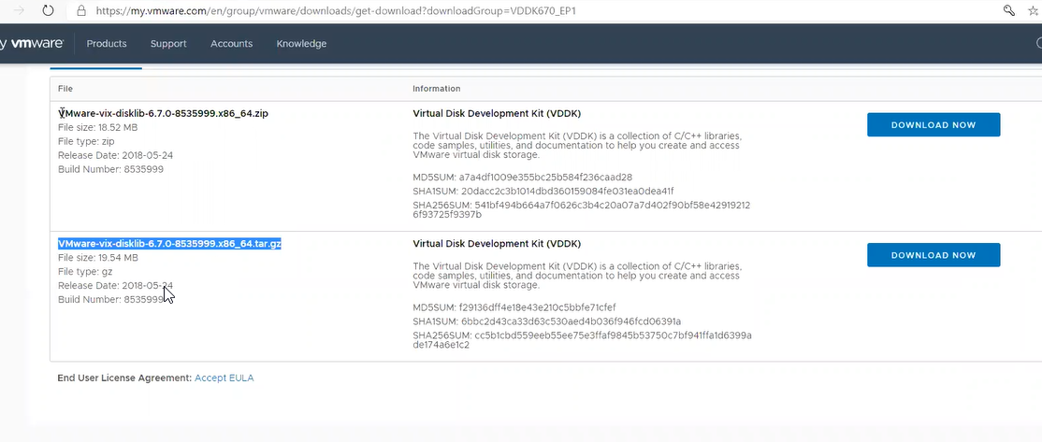

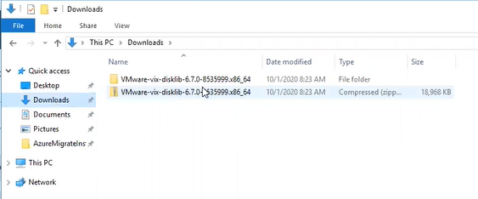

Open the folder and copy the contents

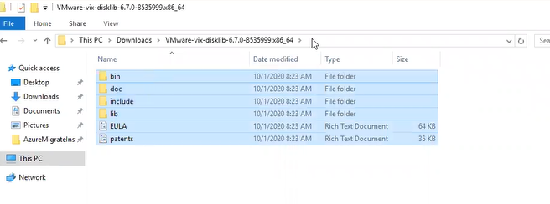

And paste in the below location



We need to register with azure migrate

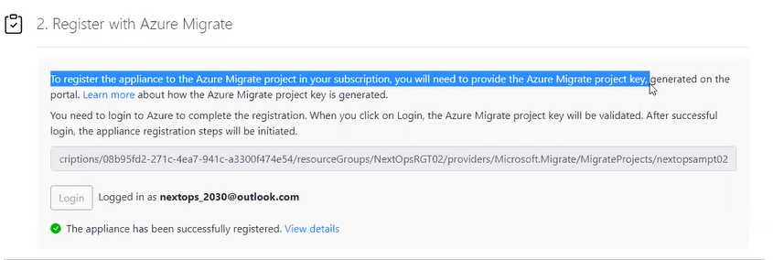

For that we need keys

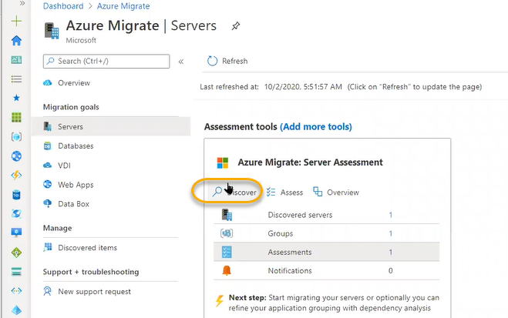

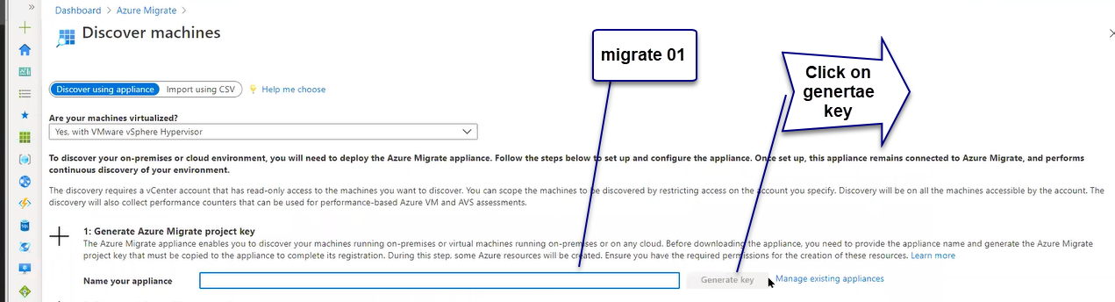

Migrare 01 is the name of which in which your migrating as shown below and after a key is generated at the name of your appliance box

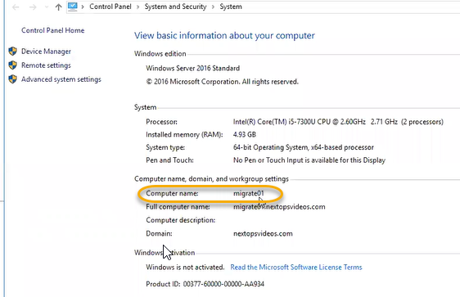

And paste it in the below highlighted box

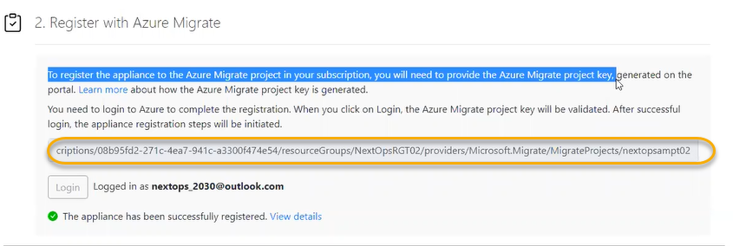

And if you click on the Login as shown above screenshot new window will be opened and OTP automatic key is generated and it will ask you to login to Azure that shows the message as loginned as xxxxx

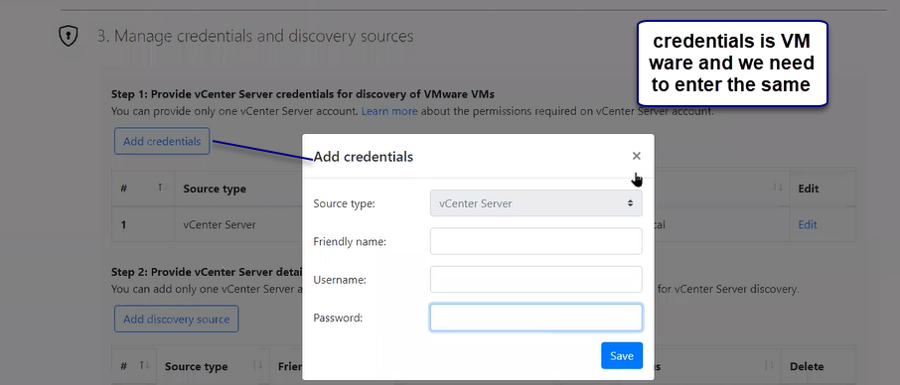

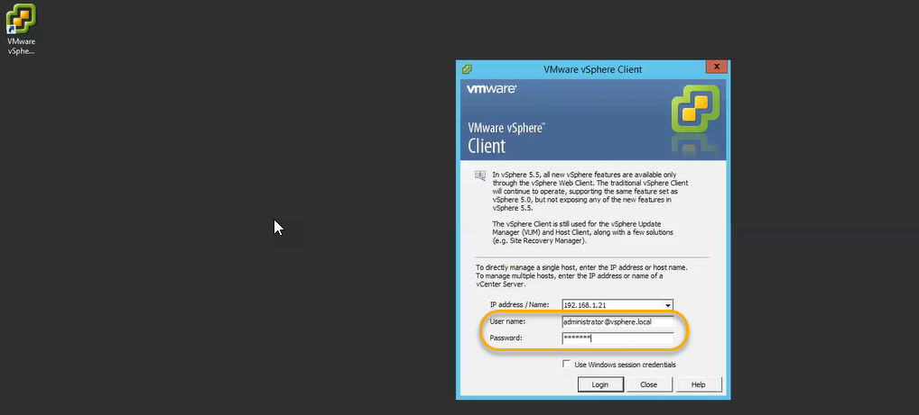

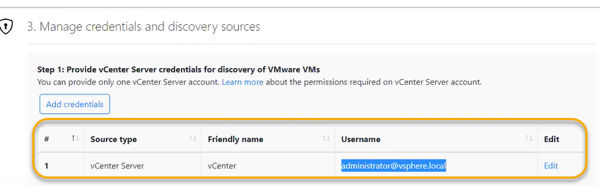

We need to enter the ip address

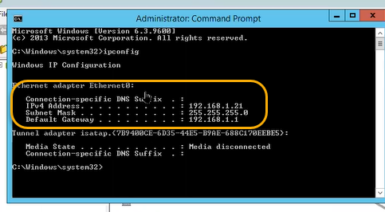

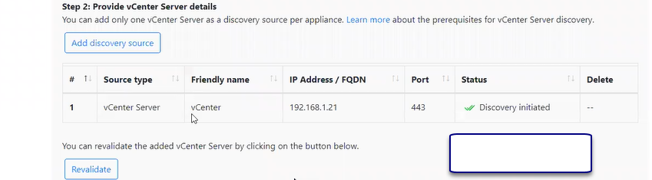

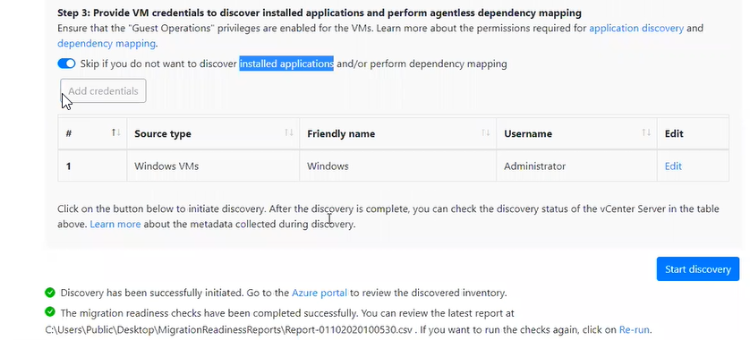

This process is for assignment and discovering

And we see the same In the portal

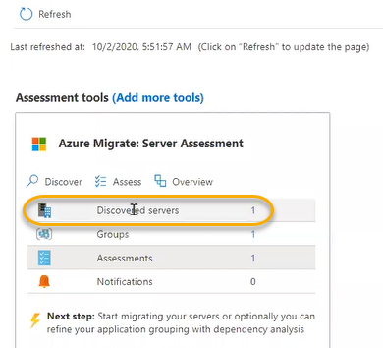

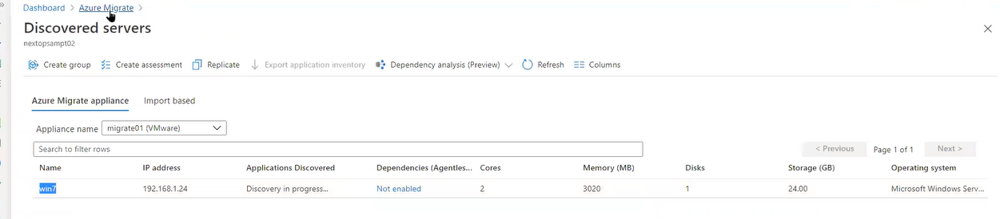

Discovers of applications will take up to 24 hours

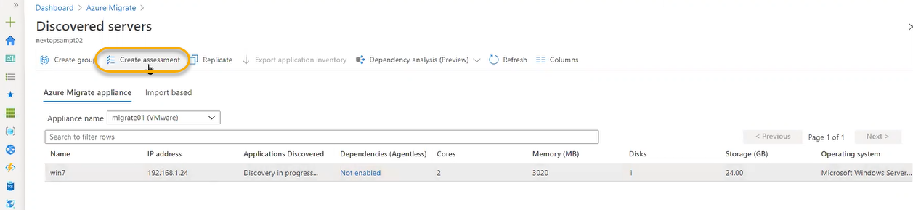

Assignment name and properties will be there we need to mention where the replicated machine to be deployed in Azure

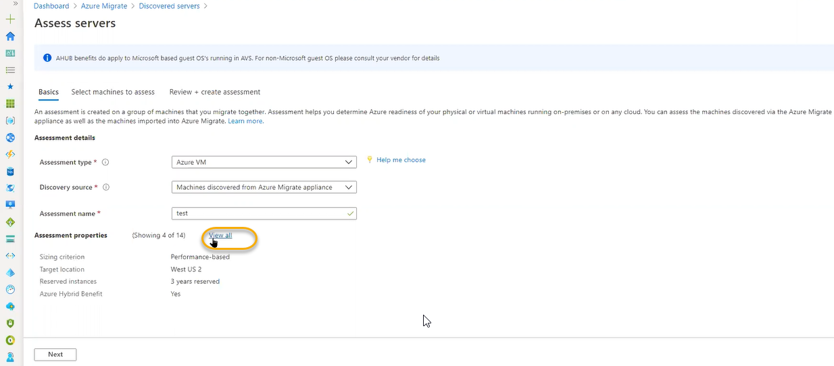

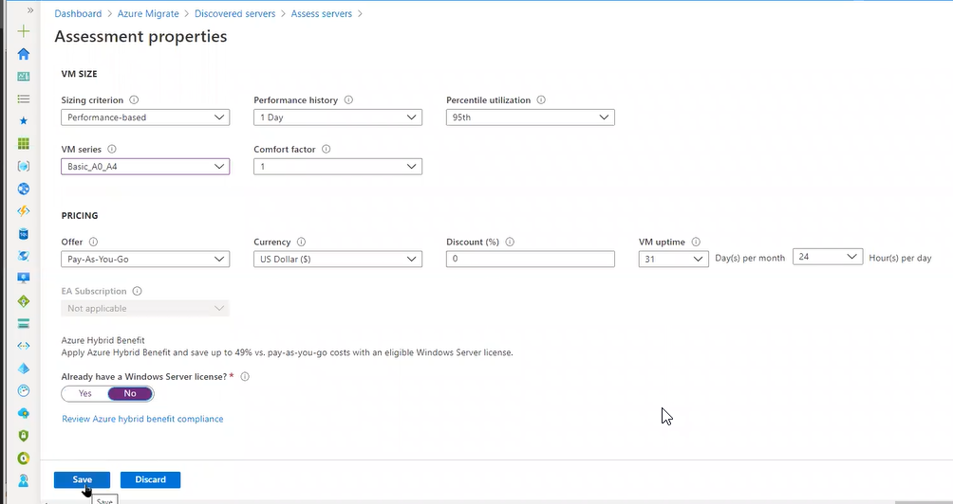

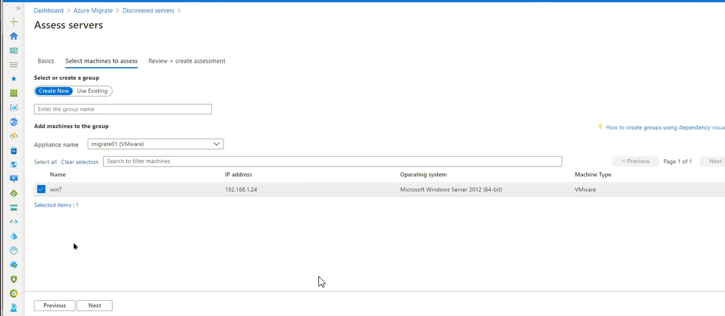

Review and create > create Assignment

Group is created

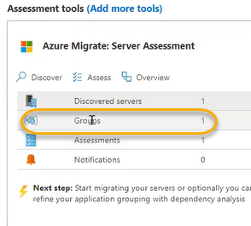

Assignments : Click on Assessments and which machines are ready or not if it is migrating to Azure then we need to know if it is ready or not

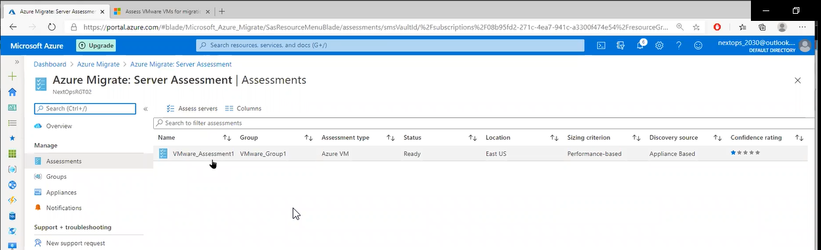

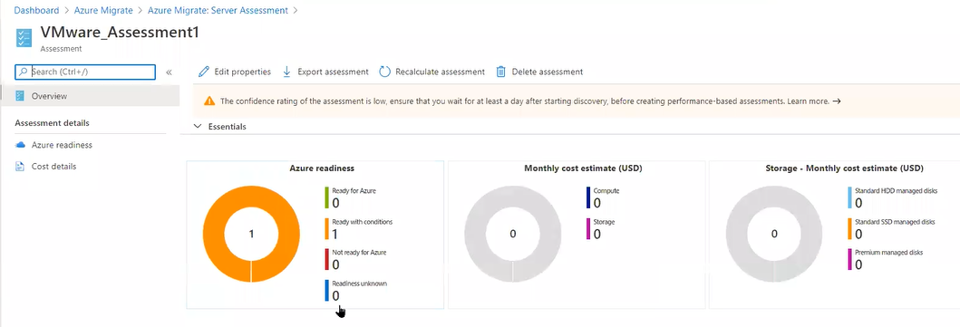

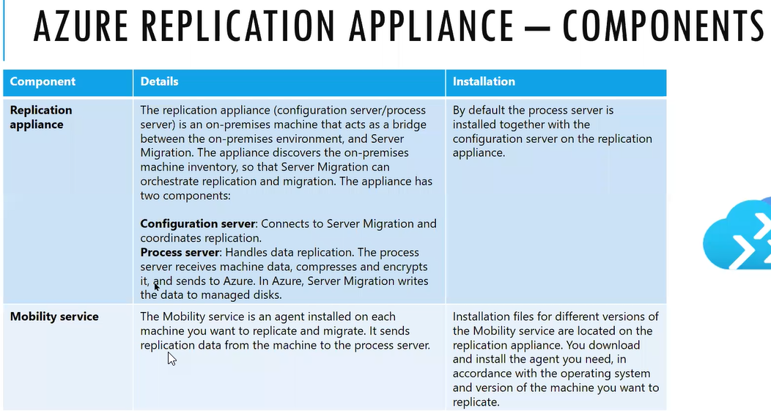

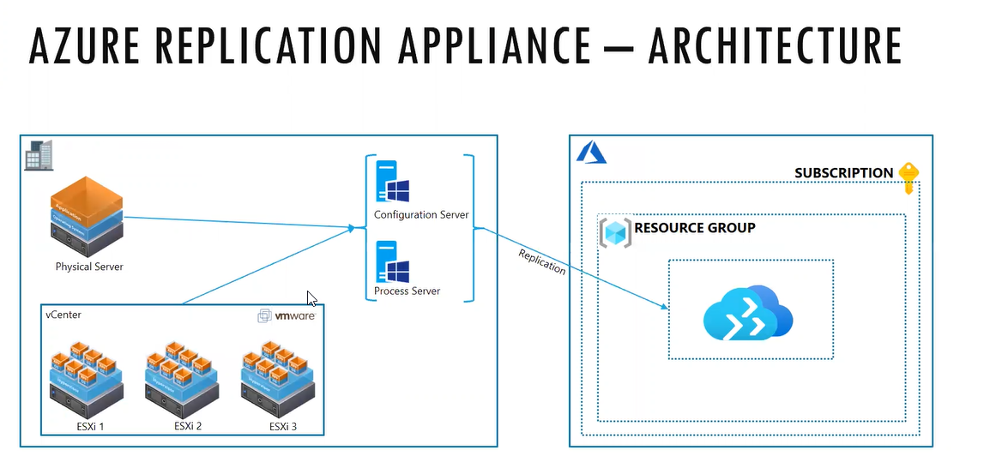

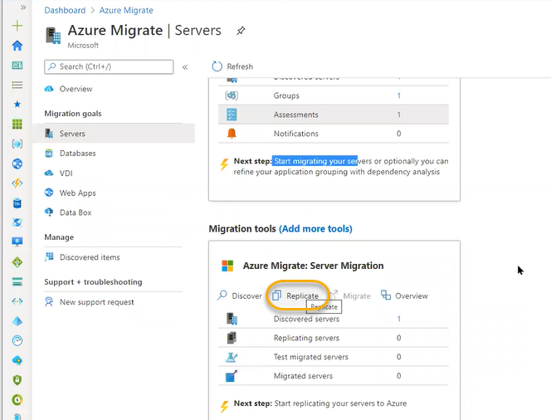

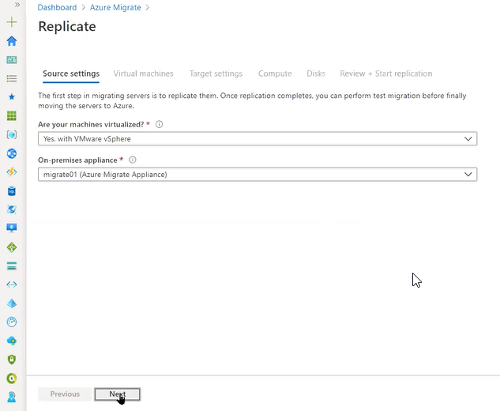

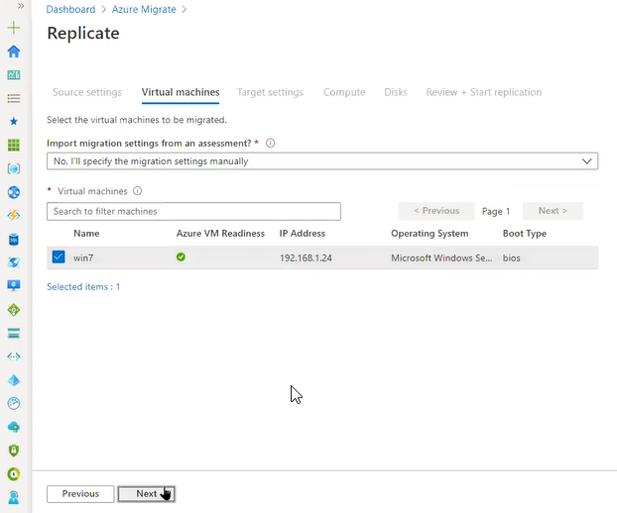

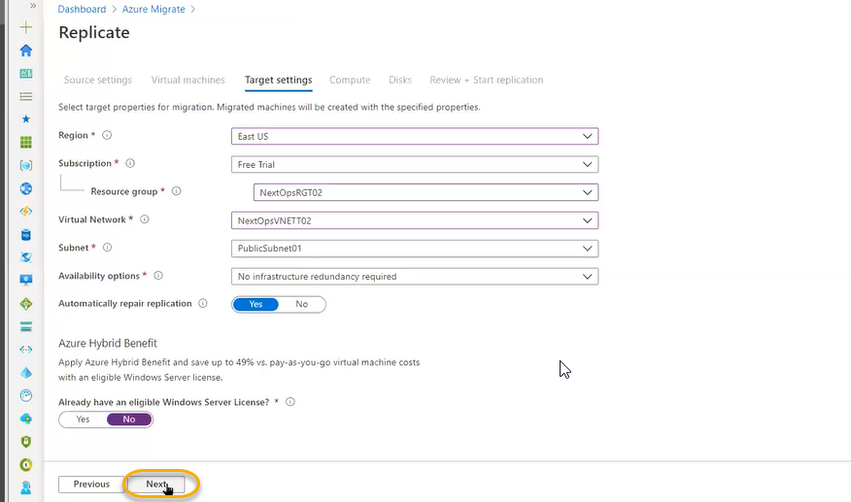

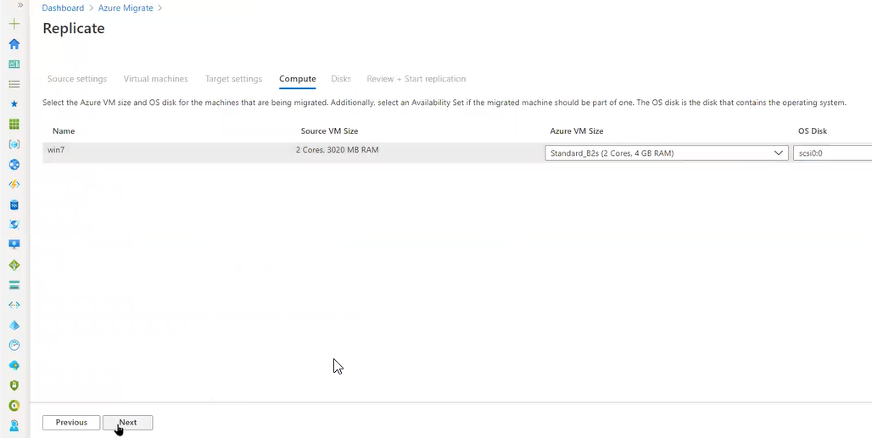

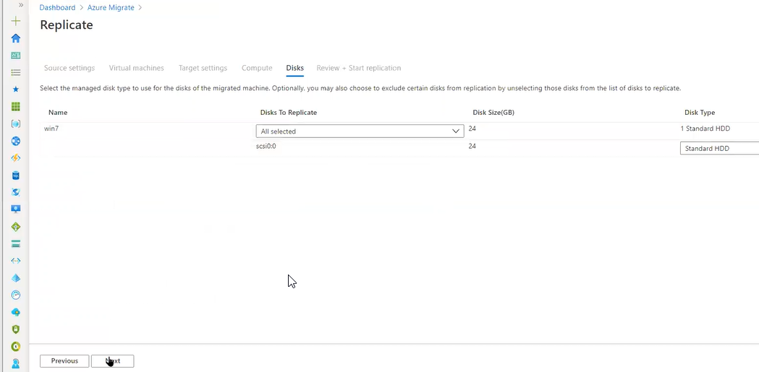

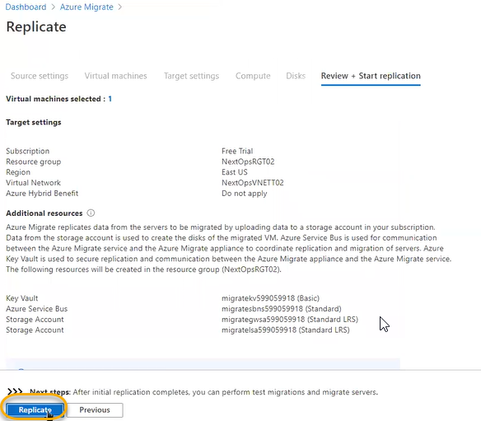

How to handle migration

1. If we have VM ware infrastructure/physical server for initial assignment it will take time and we need analyses how many VM are there, requirement of resources , workload and we need maintain complete inventory/ or if we have monitor tool we need to do complete analysis and for vmware there is vmpowercli we can do export for cpu, memory allocation. O.S will be uploaded and with In the past 4 years how the VM ware are performing we need to do assignment
2. We will report to this management after meeting we need to tell cost estimation and we can decide later
3. We need to do inform/meeting with the development team (owing the vmware machines)
4. We need to give POC (Proof of concept) and we need to start migrating of 50 machines which has less impact or not of production server
5. Minimum time taken server is 1 hour to upload and we need to plan this activity in the weekends
6. We will shutdown on premises VMs and we need to do inform to concerned person
7. And we need to test the VMs if they are working or not
8. If it is working, we will remove/decompose on premises VM
9. WE NEED TO CONVINENCE MORE AND MORE PEOPLE
10. From batches to batches we will do migrations over the one year to 2 for completing the process
11. If it is a big process/migrating 1 TB we need to take a offline

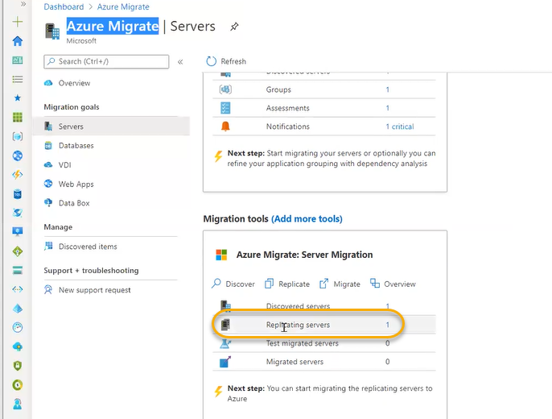

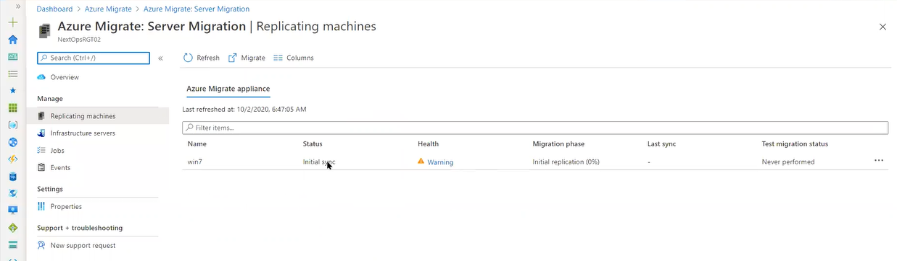

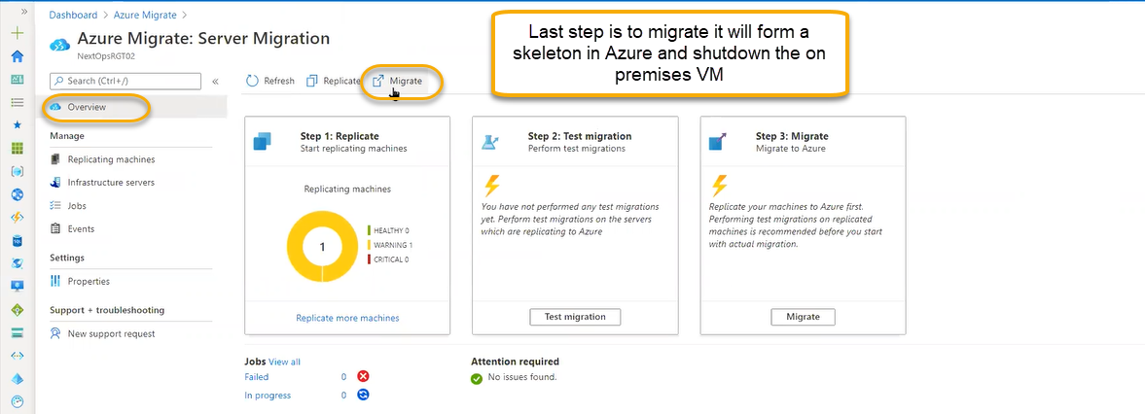

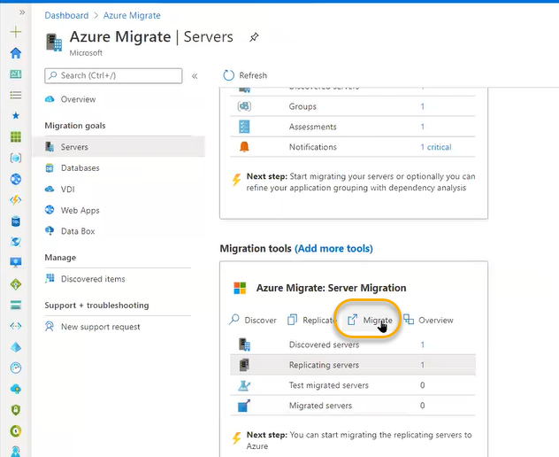

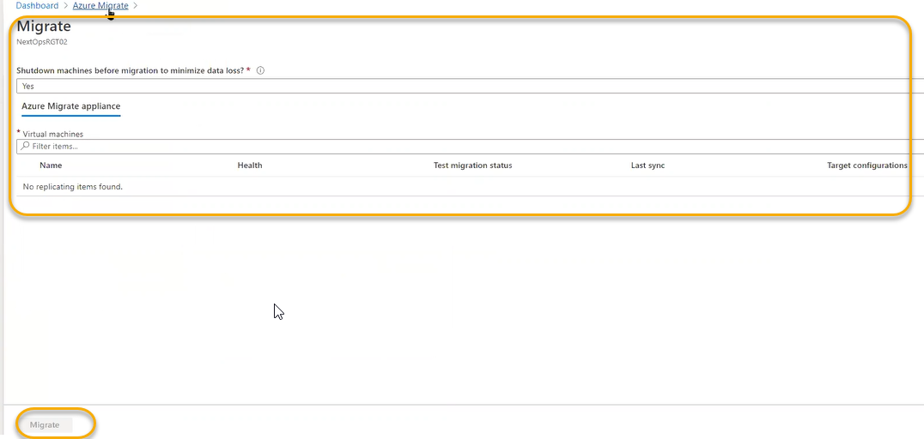

Webapps

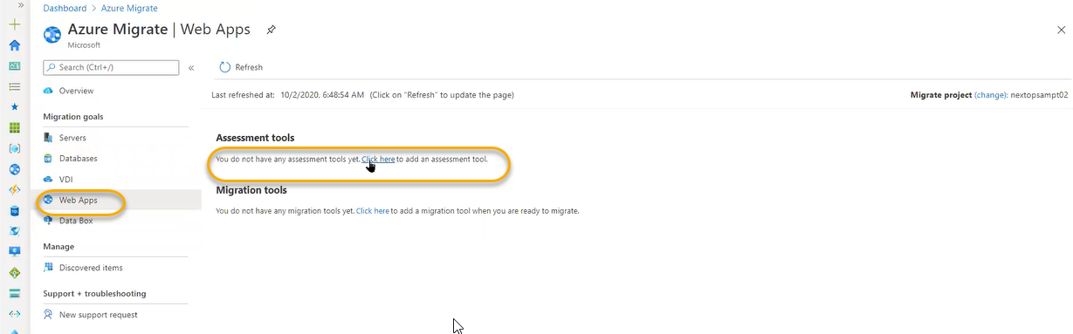

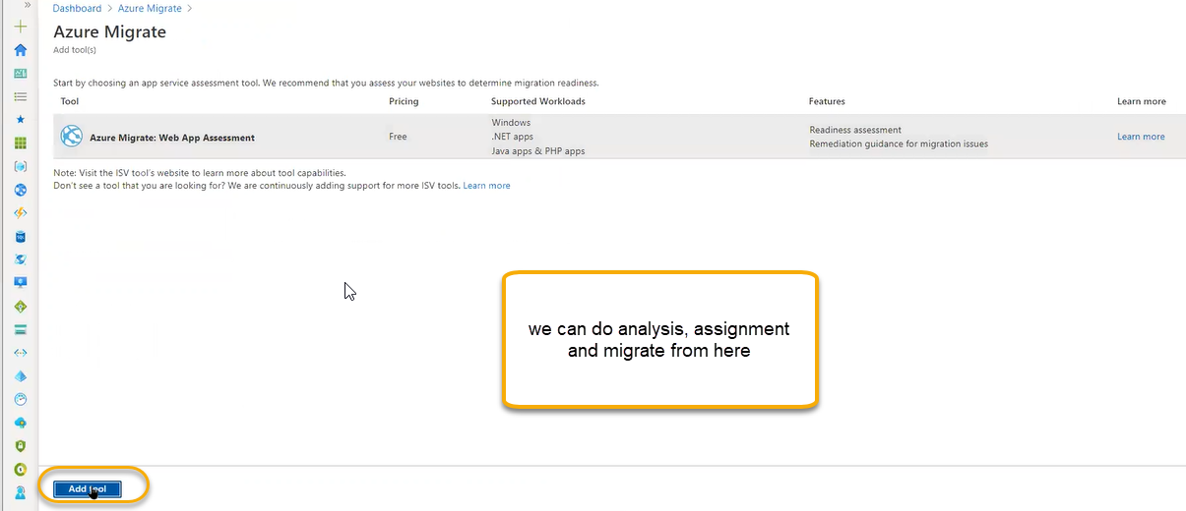

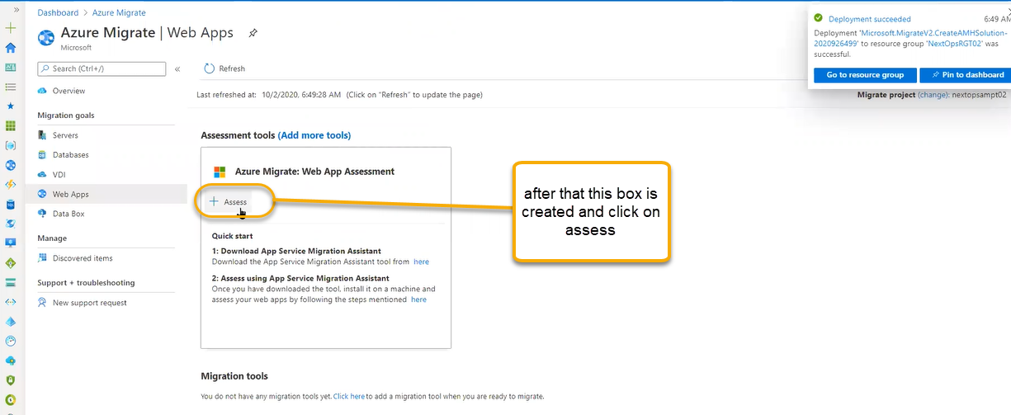

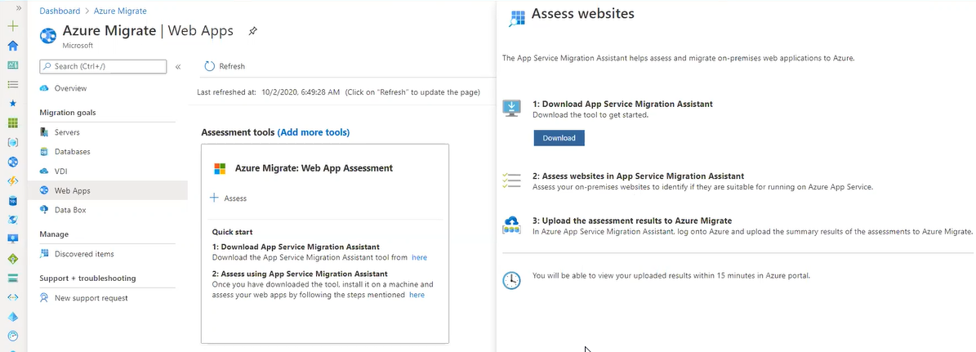

Or we can download it from online which is simple process



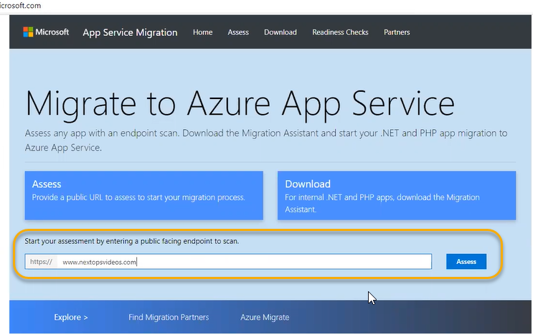

Click on the Assess

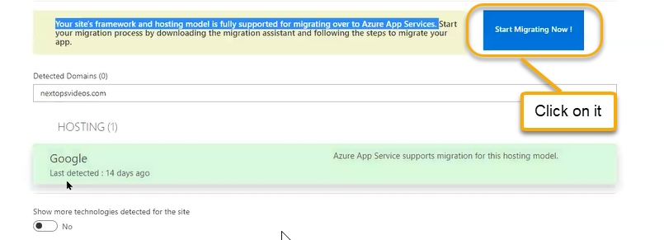

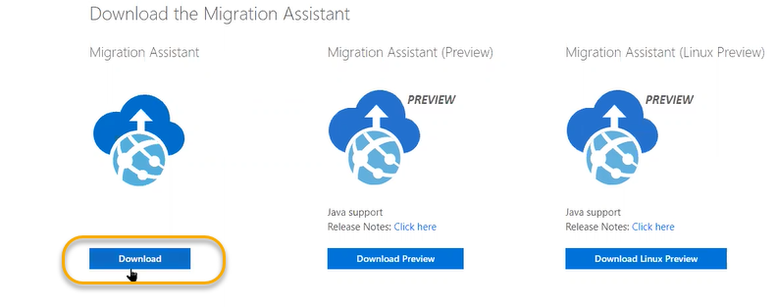

Database

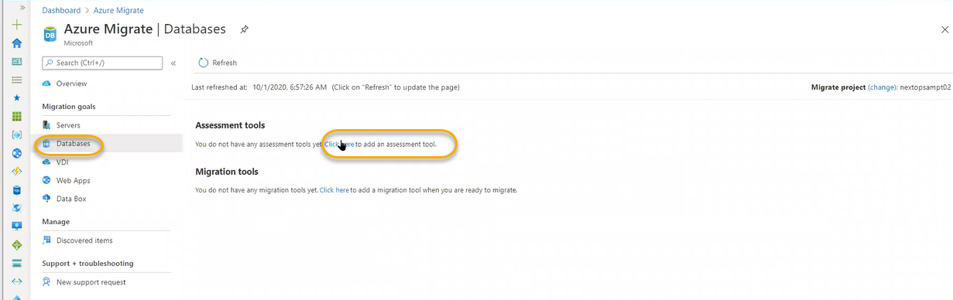

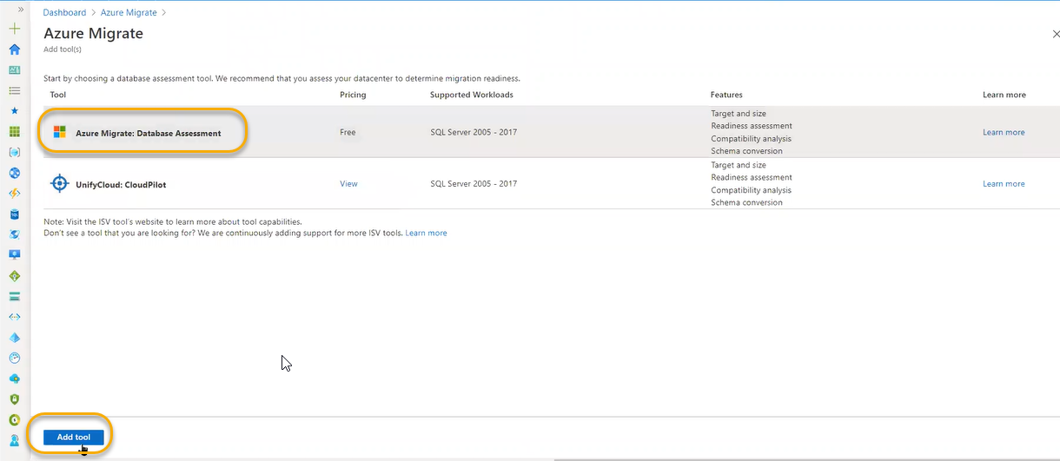

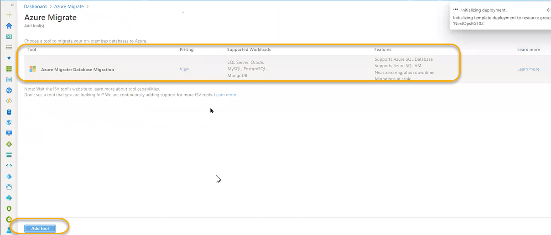

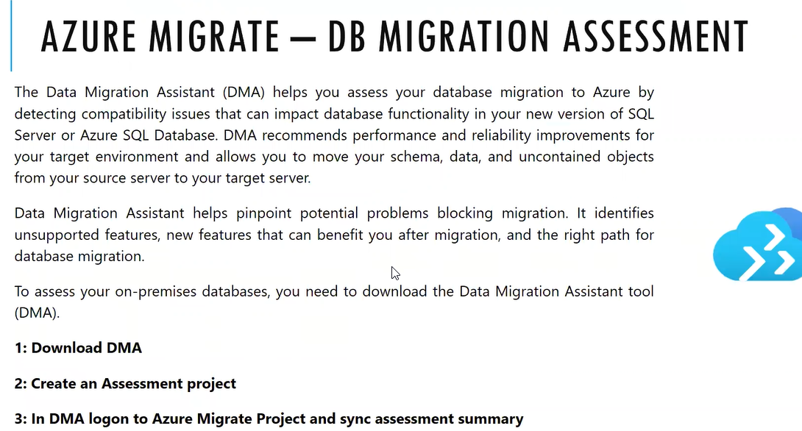

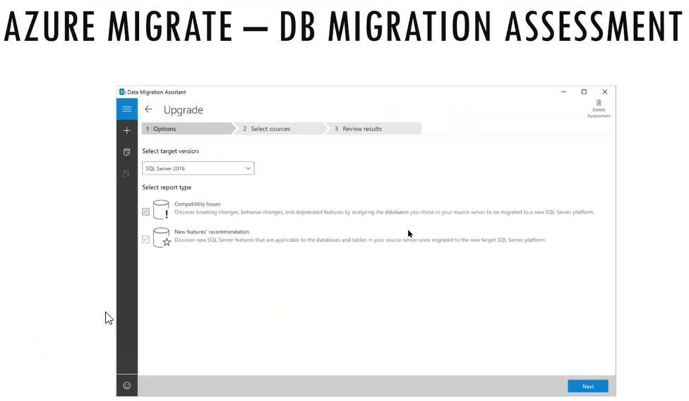

In the on premises the DB is completely running in the VM

We are bringing this to PAAS Platform- Azure SQL DB

DB Migration assessment will do comparison if it is compatibility or not

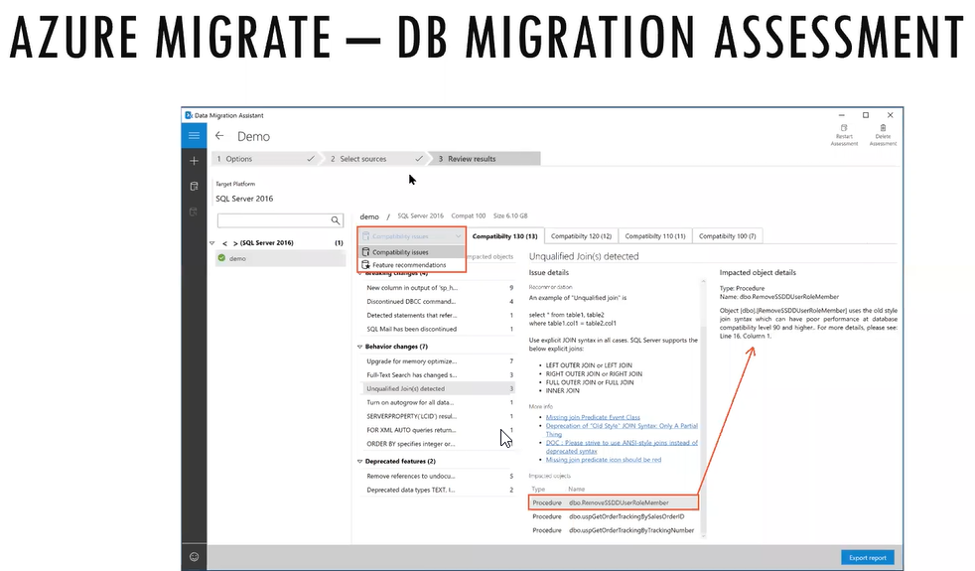

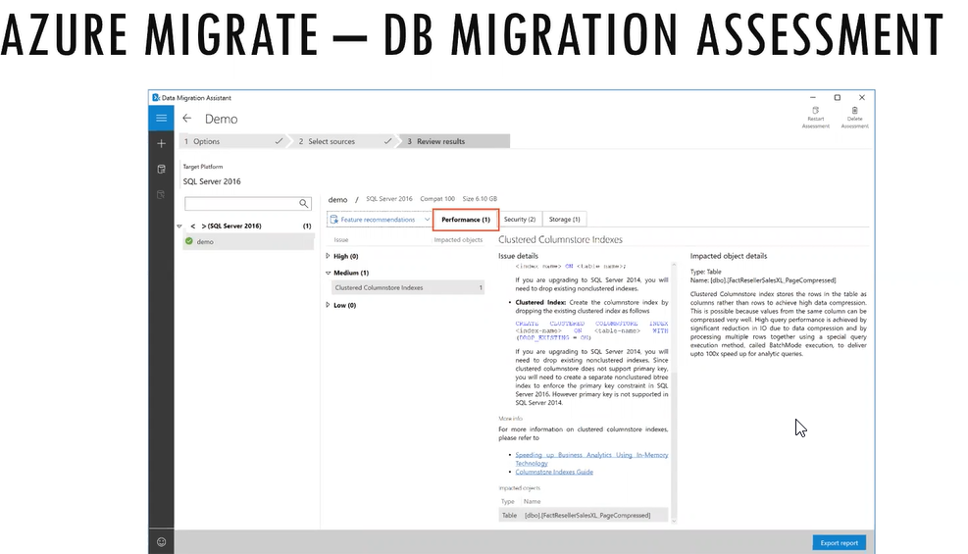

We cannot do migrate when ever we want because it is headache process

Because after patching we cannot know if it works or not

It effects health condition

However, in the background azure sql will run up to date

VDI VDI is like VM server instead of running server VMs we will run the desktop VMS

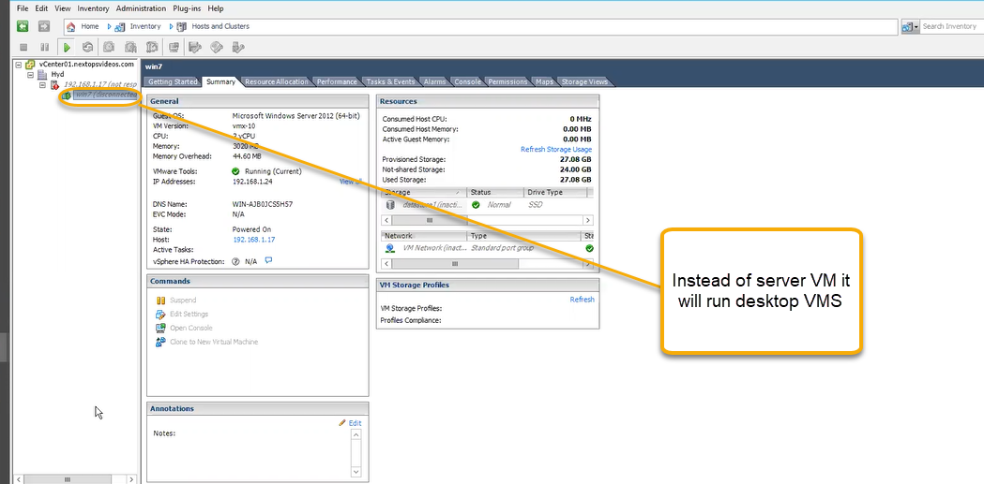

If the desktop should be run in client data center we cannot do copy in the machines